IP Recovery Using Multiple Routing Configurations

A project report submitted
For PROJECT LAB

BY
P.HARIKA D.NAGESWARA RAO
Reg: 680755032 Reg: 680755018

R.ABHILASH REDDY SH.NAGUL MEERA
Reg: 680755002 Reg: 680755005

B.HARITHA
680755033
Under the esteemed guidance of

A.YESU BABU (Phd)Head Of the Dept
P.PANDARINATH(Assoc.professor)



Department of Computer science & Engineering
Sir C.R.Reddy College of Engineering
(Affiliated to Andhra university)
eluru.
2009-2010

Department of Computer Science & Engineering

CERTIFICATE
This is to certify that this project work titled “INTRUSION DETECTION SYSTEM” has been successfully completed by the following students

P.HARIKA D.NAGESWARA RAO
Reg: 680755032 Reg: 680755018

R.ABHILASH REDDY SH.NAGUL MEERA
Reg: 680755002 Reg: 680755061

B.HARITHA
680755033
This work has been carried during the academic year 2010-11 for project lab in IV/IV II semester Computer Science and Engineering.

PROJECT GUIDE HEAD OF THE DEPARTMENT

ABSTRACT

As the Internet takes an increasingly central role in our communications infrastructure, the slow convergence of routing protocols after a network failure becomes a growing problem. To assure fast recovery from link and node failures in IP networks, we present a new recovery scheme called Multiple Routing Configurations (MRC).. It can be implemented with only minor changes to existing solutions. In this paper we present MRC, and analyze its performance with respect to scalability, backup path lengths, and load distribution after a failure. We also show how an estimate of the traffic demands in the network can be used to improve the distribution of the recovered traffic, and thus reduce the chances of congestion when MRC is used.

CONTENTS
Page
- Introduction 1
- Intrusion Detection System and Intruder 3
2.1 Tasks of IDS 3
2.2 Classification of IDS 4
2.3 IDS vs. Firewall 10
2.4 Intrusion Attacks and Scenario 11
2.5 Tools Used by Intruder 12
2.6 Intrusion Detection Technique 13
2.7 Attacks that can be Detected by IDS 14
- Detection Tools and Case Studies 18
3.1 Packet Sniffers 18
3.2 Port Scanners 20
3.3 Case Study: SNORT 21
3.4 Case Study: Cyberoam 24
- Our Implementation of NIDS 27
4.1 Features of our Implementation 27
4.2 Requirements and Tools 27
4.3 Placement of IDS 28
4.4 Rule Creator 28
4.5 Working of our IDS 31
- Conclusion 32
- References 33
- Acknowledgement 35

1. INTRODUCTION

IN recent years the Internet has been transformed from a special purpose network to a ubiquitous platform for a wide range of everyday communication services. The demands on Internet reliability and availability have increased accordingly. A disruption of a link in central parts of a network has the potential to affect hundreds of thousands of phone conversations or TCP connections, with obvious adverse effects. The ability to recover from failures has always been a central design goal in the Internet [1]. IP networks are intrinsically robust, since IGP routing protocols like OSPF are designed to update the forwarding information based on the changed topology after a failure. This re-convergence assumes full distribution of the new link state to all routers in the network domain. When the new state information is distributed, each router individually calculates new valid routing tables. This network-wide IP re-convergence is a time consuming process, and a link or node failure is typically followed by a period of routing instability. During this period, packets may be dropped due to invalid routes. This phenomenon has been studied in both IGP [2] and BGP context [3], and has an ad-verse effect on real-time applications [4]. Events leading to a re-convergence have been shown to occur frequently [5]. Much effort has been devoted to optimizing the different steps of the convergence of IP routing, i.e., detection, dissemination of information and shortest path calculation, but the convergence time is still too large for applications with real time demands [6]. A key problem is that since most network failures are short lived [7], too rapid triggering of the re-convergence process can cause route appling and increased network instability [2]. The IGP convergence process is slow because it is reactive and global. It reacts to a failure after it has happened, and it involves all the routers in the domain. In this paper we present a new scheme for handling link and node failures in IP networks. Multiple Routing Con-gurations (MRC) is a proactive and local process, and a link or node failure is typically followed by a period of routing instability. During this period, packets may be dropped due to invalid routes. This phenomenon has been studied in both IGP [2] and BGP context [3], and has an adverse effect on real-time applications [4]. Events leading to a re-convergence have been shown to occur frequently [5]. Much effort has been devoted to optimizing the different steps of the convergence of IP routing, i.e., detection, dissemination of information and shortest path calculation, but the convergence time is still too large for applications with real time demands [6]. A key problem is that since most network failures are short lived [7], too rapid triggering of the re-convergence process can cause route mapping and increased network instability [2]. The IGP convergence process is slow because it is reactive and global. It reacts to a failure after it has happened, and it involves all the routers in the domain. In this paper we present a new scheme for handling link and node failures in IP networks. Multiple Routing Configurations(MRC) is a proactive and local, the main idea of MRC is to use the network graph and the associated link weights to produce a small set of backup network configurations. The link weights in these backup configurations are manipulated so that for each link and node failure, and regardless of whether it is a link or node failure, the node that detects the failure can safely forward the incoming packets to-wards the destination on an alternate link. MRC assumes that the network uses shortest path routing and destination based hop-by-hop forwarding. The shifting of traffic to links bypassing the failure can lead to congestion and packet loss in parts of the network [9]. This limits the time that the proactive recovery scheme can be used to forward traffic before the global routing protocol is informed about the failure, and hence reduces the chance that a transient failure can be handled without a full global routing re-convergence. Ideally, a proactive recovery scheme should not only guarantee connectivity after a failure, but also do so in a manner that does not cause an unacceptable load distribution. This requirement has been noted as being one of the principal challenges for pre-calculated IP recovery schemes [10]. With MRC, the link weights are set individually in each backup configuration. This gives great flexibility with respect to how the recovered traffic is routed. The backup conjurations used after a failure is selected based on the failure instance, and thus we can choose link weights in the backup configurations that are well suited for only a subset of failure instances.

2. SOFTWARE REQUIREMENTS SPECIFICATION
2.1. Introduction
2.1.1. Purpose:
The purpose of this SRS is to enable functional and non functional requirements.
2.1.2.Scope
Objective:
As the Internet takes an increasingly central role in our communications infrastructure, the slow convergence of routing protocols after a network failure becomes a growing problem. To assure fast recovery from link and node failures in IP networks, we present a new recovery scheme called Multiple Routing Configurations (MRC).. It can be implemented with only minor changes to existing solutions. In this paper we present MRC, and analyze its performance with respect to scalability, backup path lengths, and load distribution after a failure. We also show how an estimate of the traffic demands in the network can be used to improve the distribution of the recovered traffic, and thus reduce the chances of congestion when MRC is used.
Requirements:
Software Requirements:
- FRONT END : JAVA, SWING
- TOOLS USED : JFRAME BUILDER
- OPERATING SYSTEM: WINDOWS XP
Hardware Requirements:
- PROCESSOR : PENTIUM IV 2.6 GHz
- RAM : 512 MB
- MONITOR : 15”
- HARD DISK : 20 GB
- CDDRIVE : 52X
- KEYBOARD : STANDARD 102 KEYS
- MOUSE : 3 BUTTONS
Functional Requirements:

- Server
- Client
- Routers

- Server:

- It will receive the data send by the client which came from the active router.
- It can have any number of clients.

- Client:

- This module is used to send the data to server through routers
- It will provide user friendly interface to send the data to the required destination

- Routers:

- These are placed in between server and client to transfer the data.
- Whenever client send the data to the server it will pass through any one router.
- If the router is failed the data will be transferred through another router to reduce the system failure.
Functional Requirements should include:
- Descriptions of data to be entered into the system
- Descriptions of operations performed by each screen
- Descriptions of work-flows performed by the system
- Descriptions of system reports or other outputs
- Who can enter the data into the system?
- How the system meets applicable regulatory requirements
The functional specification is designed to be read by a general audience. Readers should understand the system, but no particular technical knowledge should be required to understand the document.

Examples of Functional Requirements:

Functional requirements should include functions performed by specific screens, outlines of work-flows performed by the system and other business or compliance requirements the system must meet.
Interface requirements
- Field accepts numeric data entry
- Field only accepts dates before the current date
- Screen can print on-screen data to the printer

Business Requirements
- Data must be entered before a request can approved
- Clicking the Approve Button moves the request to the Approval Workflow
- All personnel using the system will be trained according to internal training strategies

Regulatory/Compliance Requirements
- The database will have a functional audit trail
- The system will limit access to authorized users
- The spreadsheet can secure data with electronic signatures

Security Requirements
- Member of the Data Entry group can enter requests but not approve or delete requests
- Members of the Managers group can enter or approve a request, but not delete requests
- Members of the Administrators group cannot enter or approve requests, but can delete requests
The functional specification describes what the system must do; how the system does it is described in the Design Specification.
If a User Requirement Specification was written, all requirements outlined in the user requirement specification should be addressed in the functional requirements.

Non Functional Requirements:

All the other requirements which do not form a part of the above specification are categorized as Non-Functional Requirements.
A system may be required to present the user with a display of the number of records in a database. This is a functional requirement.
How up-to-date this number needs to be is a non-functional requirement. If the number needs to be updated in real time, the system architects must ensure that the system is capable of updating the displayed record count within an acceptably short interval of the number of records changing.
Sufficient network bandwidth may also be a non-functional requirement of a system.
Other examples:
- Accessibility
- Availability
- Backup
- Certification
- Compliance
- Configuration Management
- Documentation
- Disaster Recovery
- Efficiency (resource consumption for given load)
- Effectiveness (resulting performance in relation to effort)
- Extensibility (adding features, and carry-forward of customizations at next major version upgrade)
- Failure Management
- Interoperability
- Maintainability
- Modifiability
- Open Source
- Operability
- Performance
- Platform compatibility
- Price
- Portability
- Quality (e.g. Faults Discovered, Faults Delivered, Fault Removal Efficacy)
- Recoverability
- Resilience
- Resource constraints (processor speed, memory, disk space, network bandwidth etc.)
- Response time
- Robustness
- Scalability (horizontal, vertical)
- Security
- Software, tools, standards etc.
- Stability
- Safety
- Supportability
- Testability
- Usability by target user community
Accessibility is a general term used to describe the degree to which a product, device, service, or environment is accessible by as many people as possible. Accessibility can be viewed as the "ability to access" and possible benefit of some system or entity. Accessibility is often used to focus on people with disabilities and their right of access to the system.
Availability is the degree to which a system, subsystem, or equipment is operable and in a committable state at the start of a mission, when the mission is called for at an unknown, i.e., a random, time. Simply put, availability is the proportion of time a system is in a functioning condition.

Expressed mathematically, availability is 1 minus the unavailability.
A backup or the process of backing up refers to making copies of data so that these additional copies may be used to restore the original after a data loss event. These additional copies are typically called "backups."
Certification refers to the confirmation of certain characteristics of an object, system, or organization. This confirmation is often, but not always, provided by some form of external review, education, or assessment
Compliance is the act of adhering to, and demonstrating adherence to, a standard or regulation.

Configuration management (CM) is a field that focuses on establishing and maintaining consistency of a system's or product's performance and its functional and physical attributes with its requirements, design, and operational information throughout its life.
Documentation may refer to the process of providing evidence ("to document something") or to the communicable material used to provide such documentation (i.e. a document). Documentation may also (seldom) refer to tools aiming at identifying documents or to the field of study devoted to the study of documents and bibliographies
Disaster recovery is the process, policies and procedures related to preparing for recovery or continuation of technology infrastructure critical to an organization after a natural or human-induced disaster.
Disaster recovery planning is a subset of a larger process known as business continuity planning and should include planning for resumption of applications, data, hardware, communications (such as networking) and other IT infrastructure
Extensibility (sometimes confused with forward compatibility) is a system design principle where the implementation takes into consideration future growth. It is a systemic measure of the ability to extend a system and the level of effort required to implement the extension. Extensions can be through the addition of new functionality or through modification of existing functionality. The central theme is to provide for change while minimizing impact to existing system functions.
Interoperability is a property referring to the ability of diverse systems and organizations to work together (inter-operate).

The term is often used in a technical systems engineering sense, or alternatively in a broad sense, taking into account social, political, and organizational factors that impact system to system performance.
Maintenance is the ease with which a software product can be modified in order to:
- correct defects
- meet new requirements
- make future maintenance easier, or
- cope with a changed environment;
Open source describes practices in production and development that promote access to the end product's source materials—typically, their source code
Operability is the ability to keep equipment, a system or a whole industrial installation in a safe and reliable functioning condition, according to pre-defined operational requirements.
In a computing systems environment with multiple systems this includes the ability of products, systems and business processes to work together to accomplish a common task.
Computer performance is characterized by the amount of useful work accomplished by a computer system compared to the time and resources used.
Depending on the context, good computer performance may involve one or more of the following:
- Short response time for a given piece of work
- High throughput (rate of processing work)
- Low utilization of computing resource(s)
- High availability of the computing system or application
- Fast (or highly compact) data compression and decompression
- High bandwidth / short data transmission time
Price in economics and business is the result of an exchange and from that trade we assign a numerical monetary value to a good, service or asset
Portability is one of the key concepts of high-level programming. Portability is the software-code base feature to be able to reuse the existing code instead of creating new code when moving software from an environment to another. When one is targeting several platforms with the same application, portability is the key issue for development cost reduction.
Quality is the common element of the business definitions is that the quality of a product or service refers to the perception of the degree to which the product or service meets the customer's expectations. Quality has no specific meaning unless related to a specific function and/or object. Quality is a perceptual, conditional and somewhat subjective attribute.
Reliability may be defined in several ways:
- The idea that something is fit for purpose with respect to time;
- The capacity of a device or system to perform as designed;
- The resistance to failure of a device or system;
- The ability of a device or system to perform a required function under stated conditions for a specified period of time;
- The probability that a functional unit will perform its required function for a specified interval under stated conditions.
- The ability of something to "fail well" (fail without catastrophic consequences
Resilience is the ability to provide and maintain an acceptable level of service in the face of faults and challenges to normal operation.
These services include:
- supporting distributed processing
- supporting networked storage
- maintaining service of communication services such as
  - video conferencing
  - instant messaging
  - online collaboration
- access to applications and data as needed

Response time perceived by the end user is the interval between
(a) The instant at which an operator at a terminal enters a request for a response from a computer and
(b) The instant at which the first character of the response is received at a terminal.
In a data system, the system response time is the interval between the receipt of the end of transmission of an inquiry message and the beginning of the transmission of a response message to the station originating the inquiry.
Robustness is the quality of being able to withstand stresses, pressures, or changes in procedure or circumstance. A system or design may be said to be "robust" if it is capable of coping well with variations (sometimes unpredictable variations) in its operating environment with minimal damage, alteration or loss of functionality.
The concept of scalability applies to technology and business settings. Regardless of the setting, the base concept is consistent - The ability for a business or technology to accept increased volume without impacting the system.
In telecommunications and software engineering, scalability is a desirable property of a system, a network, or a process, which indicates its ability to either handle growing amounts of work in a graceful manner or to be readily enlarged.
Security is the degree of protection against danger, loss, and criminals.
Security has to be compared and contrasted with other related concepts: Safety, continuity, reliability. The key difference between security and reliability is that security must take into account the actions of people attempting to cause destruction.
Security as a state or condition is resistance to harm. From an objective perspective, it is a structure's actual (conceptual and never fully knowable) degree of resistance to harm.
Stability - it means much of the objects will be stable over time and will not need changes.

Safety is the state of being "safe", the condition of being protected against physical, social, spiritual, financial, political, emotional, occupational, psychological, educational or other types or consequences of failure, damage, error, accidents, harm or any other event which could be considered non-desirable. This can take the form of being protected from the event or from

exposure to something that causes health or economical losses. It can include protection of people or of possessions
Supportability (also known as serviceability) is one of the aspects of RASU (Reliability, Availability, Serviceability, and Usability)). It refers to the ability of technical support personnel to install, configure, and monitor products, identify exceptions or faults, debug or isolate faults to root cause analysis, and provide hardware or software maintenance in pursuit of solving a problem and restoring the product into service. Incorporating serviceability facilitating features typically results in more efficient product maintenance and reduces operational costs and maintains business continuity.

Testability, a property applying to an empirical hypothesis, involves two components: (1) the logical property that is variously described as contingency, defeasibility, or falsifiability, which means that counter examples to the hypothesis are logically possible, and (2) the practical feasibility of observing a reproducible series of such counter examples if they do exist. In short it refers to the capability of an equipment or system to be tested
Usability is a term used to denote the ease with which people can employ a particular tool or other human-made object in order to achieve a particular goal. In human-computer interaction and computer science, usability often refers to the elegance and clarity with which the interaction with a computer program or a web site is designed.

ANALYSIS
Analysis is the phase where the system observes the feasibility of system. Development is the cost efficient based on the mamagement approval,and then design,codingphases will be executed.
Analysis phase delivers requirement specification.The system specification serves as an interface between designer and developer as well as between developer and user.This describes external behavior of software without bothering the internal implementation.
Problem analysis is performed to getting a clear understanding of needs of the clients and the user and what exactly desired from the software.Analysis leads to actual specification.During the process of analysis a massive amount of information is collected in the form of interviews,questionnaires and information from documentation and so korth.One of the information can be effectively evaluated for completeness and consistency.

Existing System:
Existing work on load distribution in connectionless IGP networks has either focused on the failure free case or on finding link weights that work well both in the normal case and when the routing protocol has converged after a single link failure Many of the approaches listed provide elegant and efficient solutions to fast network recovery, however MRC and Not-via tunneling seems to be the only two covering all evaluated requirements. However, we argue that MRC offers the same functionality with a simpler and more intuitive approach, and leaves More room for optimization with respect to load balancing.

Proposed System:
Our proposed scheme guarantees Recovery in all single failure scenarios, using a single mechanism to handle both link and node failures, and without knowing the root cause of the failure. MRC is strictly connectionless, and assumes only destination based hop-by-hop forwarding. MRC is based on keeping additional routing information in the routers, and allows packet forwarding to continue on an alternative output link immediately after the detection of a failure.

Feasibility Study:

Preliminary investigation examines project feasibility, the likelihood the system will be useful to the organization. The main objective of the feasibility study is to test the Technical, Operational and Economical feasibility for adding new modules and debugging old running system. All systems are feasible if they are given unlimited resources and infinite time. There are aspects in the feasibility study portion of the preliminary investigation:

- Technical Feasibility
- Operation Feasibility
- Economical Feasibility

Technical Feasibility:
The technical issue usually raised during the feasibility stage of the investigation includes the following:
- Does the necessary technology exist to do what is suggested?
- Do the proposed equipments have the technical capacity to hold the data required to use the new system?
- Will the proposed system provide adequate response to inquiries, regardless of the number or location of users?
- Can the system be upgraded if developed?
- Are there technical guarantees of accuracy, reliability, ease of access and data security?

Operational Feasibility:

Proposed projects are beneficial only if they can be turned out into information systems, which will meet the organization’s operating requirements. Operational feasibility aspects of the project are to be taken as an important part of the project implementation. Some of the important issues raised are to test the operational feasibility of a project includes the following: -
- Is there sufficient support for the management from the users?
- Will the system be used and work properly if it is being developed and implemented?
- Will there be any resistance from the user that will undermine the possible application benefits?
This system is targeted to be in accordance with the above-mentioned issues. Beforehand, the management issues and user requirements have been taken into consideration. So there is no question of resistance from the users that can undermine the possible application benefits.
The well-planned design would ensure the optimal utilization of the computer resources and would help in the improvement of performance status.

Economic Feasibility:
A system can be developed technically and that will be used if installed must still be a good investment for the organization. In the economical feasibility, the development cost in creating the system is evaluated against the ultimate benefit derived from the new systems. Financial benefits must equal or exceed the costs. The system is economically feasible. It does not require any additional hardware or software.

SDLC METHDOLOGIES:

This document play a vital role in the development of life cycle (SDLC) as it describes the complete requirement of the system. It means for use by developers and will be the basic during testing phase. Any changes made to the requirements in the future will have to go through formal change approval process.
SPIRAL MODEL was defined by Barry Boehm in his 1988 article, “A spiral Model of Software Development and Enhancement. This model was not the first model to discuss iterative development, but it was the first model to explain why the iteration models.
As originally envisioned, the iterations were typically 6 months to 2 years long. Each phase starts with a design goal and ends with a client reviewing the progress thus far. Analysis and engineering efforts are applied at each phase of the project, with an eye toward the end goal of the project.

The steps for Spiral Model can be generalized as follows:
- The new system requirements are defined in as much details as possible. This usually involves interviewing a number of users representing all the external or internal users and other aspects of the existing system.
- A preliminary design is created for the new system.
- A first prototype of the new system is constructed from the preliminary design. This is usually a scaled-down system, and represents an approximation of the characteristics of the final product.
- A second prototype is evolved by a fourfold procedure:
- Evaluating the first prototype in terms of its strengths, weakness, and risks.
- Defining the requirements of the second prototype.
- Planning an designing the second prototype.
- Constructing and testing the second prototype.
- At the customer option, the entire project can be aborted if the risk is deemed too great. Risk factors might involve development cost overruns, operating-cost miscalculation, or any other factor that could, in the customer’s judgment, result in a less-than-satisfactory final product.
- The existing prototype is evaluated in the same manner as was the previous prototype, and if necessary, another prototype is developed from it according to the fourfold procedure outlined above.
- The preceding steps are iterated until the customer is satisfied that the refined prototype represents the final product desired.
- The final system is constructed, based on the refined prototype.
- The final system is thoroughly evaluated and tested. Routine maintenance is carried on a continuing basis to prevent large scale failures and to minimize down time.

The following diagram shows how a spiral model acts like:

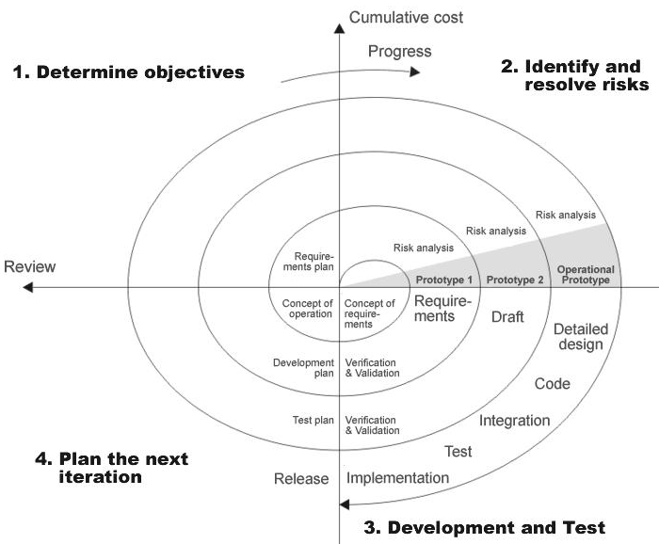

Spiral Model
SYSTEM DESIGN CONCEPTS

Contex Level DFD:

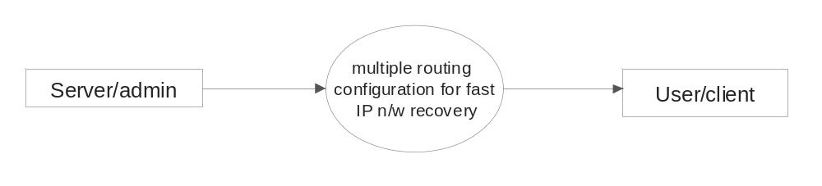

Level 1 DFD

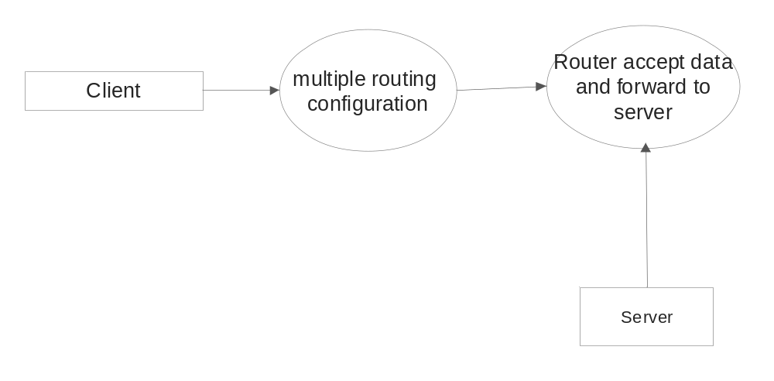

UML DIAGRAMS

Use case diagram:

The behavior of the system under development is documented in a use case model that illustrated the system’s intended functions (use cases), its surroundings (actors) and relationships between the use cases and actors.

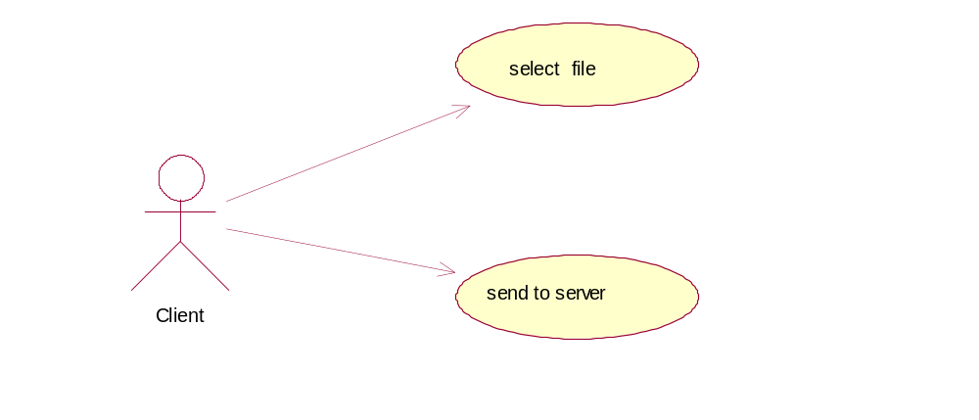

Sequence diagram:

The sequence diagram describes the overall sequence of the flow of control when there are many short methods in different classes. It shows the concurrent processes and activations.

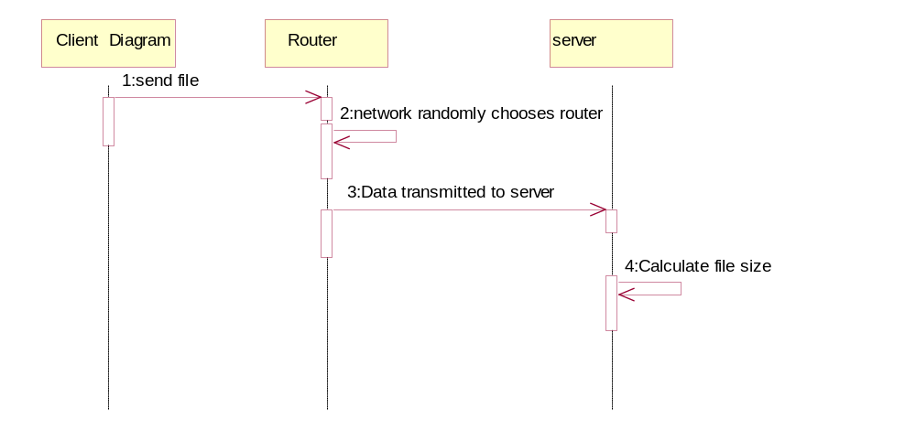
Collaboration diagram:

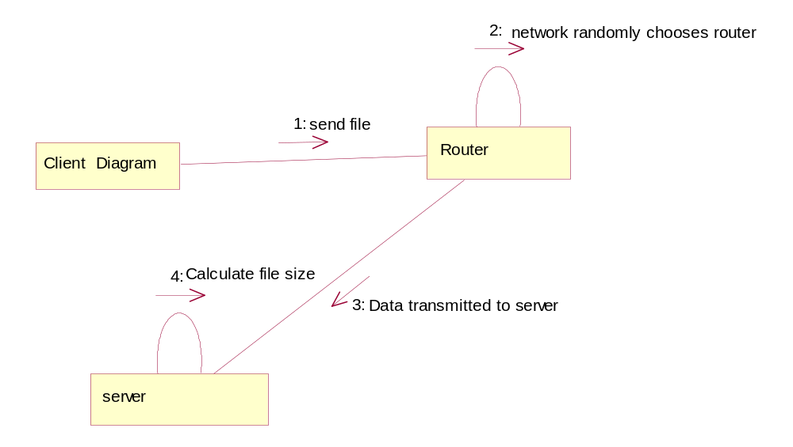

Activity diagram:

An activity diagram represents the dynamics of the system. They are used to show the flow of control from activity to activity in the system, what activities can be done in parallel and any alternate paths through the flow. It may be created to show the workflow for an operation.

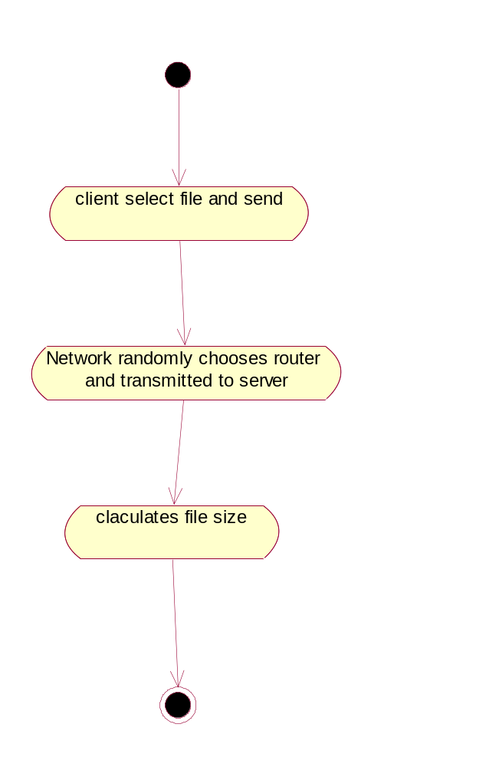

Class diagram:

Classes are depicted as boxes with three sections, the top one indicates the name of the class, the middle one lists the attributes of the class, and the third one lists the methods.
An object is any person, place, thing, concept, event, screen, or report applicable to tour system. Objects both know things (they have attributes) and they do things (they have methods). A class is a representation of an object and, in many ways; it is simply a template from which objects are created.

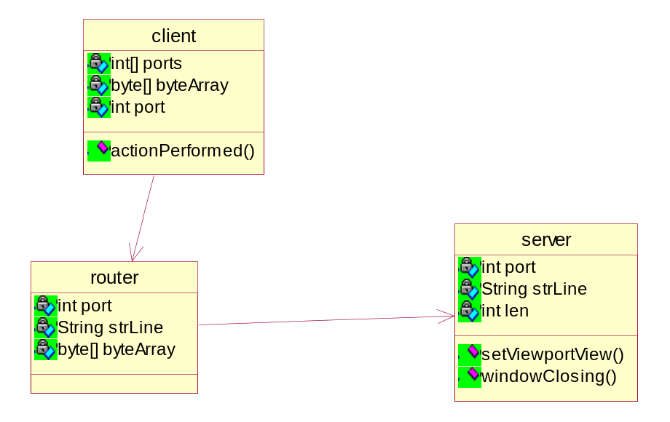

JAVA
JAVA was conceived by James Gosling, Patrick Naughton, Chirs Warth, Ed Frankland and Mike Sheridan at Microsystems. The primary motivation was the need for plot form neutral language.

FEATURES OF JAVA
1. Compiled and integrated.
2. Platform independent and portability
3. Object Oriented
4. Robust and Secure.
5. Distributed.
6. Multithreading and Interactive.
7. High Performance.
8. Dynamic and Extensible.

JAVA SERVLETS
Servlets are small programs that execute on server side of a web connection servlets dynamically extend the functionally of a web server.
Servlets are the font-line inJAVA wed application development they provide an easy way for our server side code to communicate with web-based clients.
LIFE CYCLE OF A JAVA SERVLET
Three methods are central to the life cycle of a servlet these are init(), sevice(), destroy().
1. The Servelet container creates an instance of the servlet.
2. The container calls the instances init() method.
3. If the container has a request for the servlet it calls the instances service() method. Before destroying the instance, the container calls the destroy() method. The instance is destroyed and market for garbage collection.

MORE ABOUT JAVA SEVERLETS:
The java servlet APL allows web developers to extend the functionality of a web server by writing small java programs called servlets That interact with the web server through a well defined API..
A servlet consists of mostly business logic and routines to normal relatively small datasets into HTML Java servlets are executed in there own threads. Servlets can continue to execute even after the client request that led to their invocation is completed and can thus maintain persistent information between requests.
The web server or application can be managed by a pool of threads, and can therefore avoid the over head of process creation for each request. Science servlets are written in Java ,they are portable between web servers and thus allow platform independent development of server-side application.
The Java servlet specification defines an application programming interface for communication between n the web server and the application program .The word servlet also refers to a Java program that implements the servlet interface.The program is loads into the web server when the web server starts up or when the server starts up or when the server receives a sub request for executing the servlet application.

Implementation:
MRC is based on building a small set of backup routing configurations, that are used to route recovered traffic on alternate paths after a failure. The backup configurations differ from the normal routing configuration in that link weights are set so as to avoid routing traffic in certain parts of the network. We observe that if all links attached to a node are given sufficiently high link weights, traffic will never be routed through that node. The failure of that node will then only affect traffic that is sourced at or destined for the node itself. Similarly, to exclude a link (or a group of links) from taking part in the routing, we give it infinite weight. The link can then fail without any consequences for the traffic.
Our MRC approach is threefold. First, we create a set of backup configurations, so that every network component is excluded from packet forwarding in one configuration. Second, for each configuration, a standard routing algorithm like OSPF is used to calculate configuration specific shortest paths and create forwarding tables in each router, based on the configurations. The use of a standard routing algorithm guarantees loop-free forwarding within one configuration. Finally, we design a forwarding process that takes advantage of the backup configurations to provide fast recovery from a component failure.
In our approach, we construct the backup configurations so that for all links and nodes in the network, there is a configuration where that link or node is not used to forward traffic. Thus, for any single link or node failure, there will exist a configuration that will route the traffic to its destination on a path that avoids the failed element. Also, the backup configurations must be constructed so that all nodes are reachable in all configurations, i.e., there is a valid path with a finite cost between each node pair. Shared Risk Groups can also be protected, by regarding such a group as a single component that must be avoided in a particular configuration. In Section III, we formally describe MRC and how to generate configurations that protect every link and node in a network.
Using a standard shortest path calculation, each router creates a set of configuration-specific forwarding tables. For simplicity, we say that a packet is forwarded according to a configuration, meaning that it is forwarded using the forwarding table calculated based on that configuration. In this paper we talk about building a separate forwarding table for each configuration, but we believe that more efficient solutions can be found in a practical implementation.
When a router detects that a neighbor can no longer be reached through one of its interfaces, it does not immediately inform the rest of the network about the connectivity failure. Instead, packets that would normally be forwarded over the failed interface are marked as belonging to a backup configuration, and forwarded on an alternative interface towards its destination. The selection of the correct backup configuration, and thus also the backup next-hop, is detailed in Section IV. The packets must be marked with a configuration identifier, so the routers along the path know which configuration to use. Packet marking is most easily done by using specific values in the DSCP field in the IP header. If this is not possible, other packet marking strategies like IPv6 extension headers or using a private address space and tunneling (as proposed in [11]) could be used.
It is important to stress that MRC does not affect the failurefree original routing, i.e., when there is no failure, all packets are forwarded according to the original configuration, where all link weights are normal. Upon detection of a failure, only traffic reaching the failure will switch configuration. All other traffic is forwarded according to the original configuration as normal.
If a failure lasts for more than a specified time interval, a normal re-convergence will be triggered. MRC does not interfere with this convergence process, or make it longer than normal. However, MRC gives continuous packet forwarding during the convergence, and hence makes it easier to use mechanisms that prevents micro-loops during convergence, at the cost of longer convergence times [12]. If a failure is deemed permanent, new configurations must be generated based on the altered topology.

Existing of literature survey

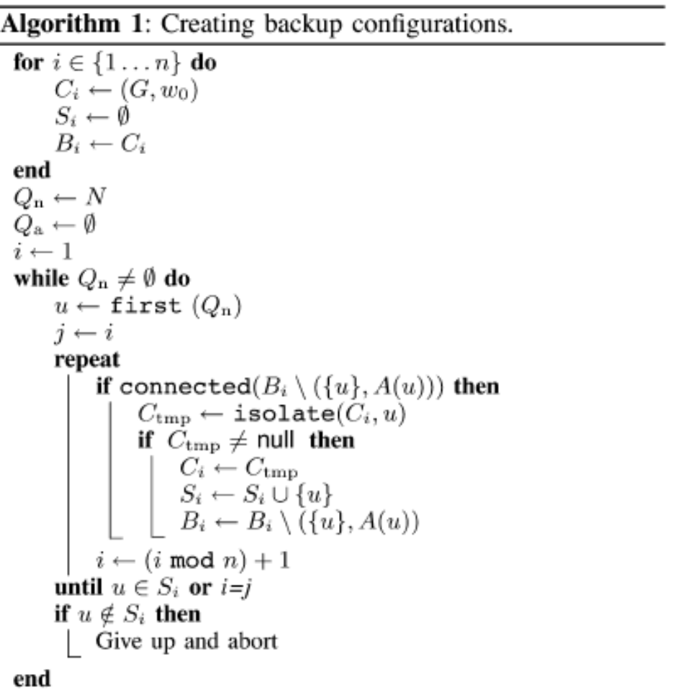
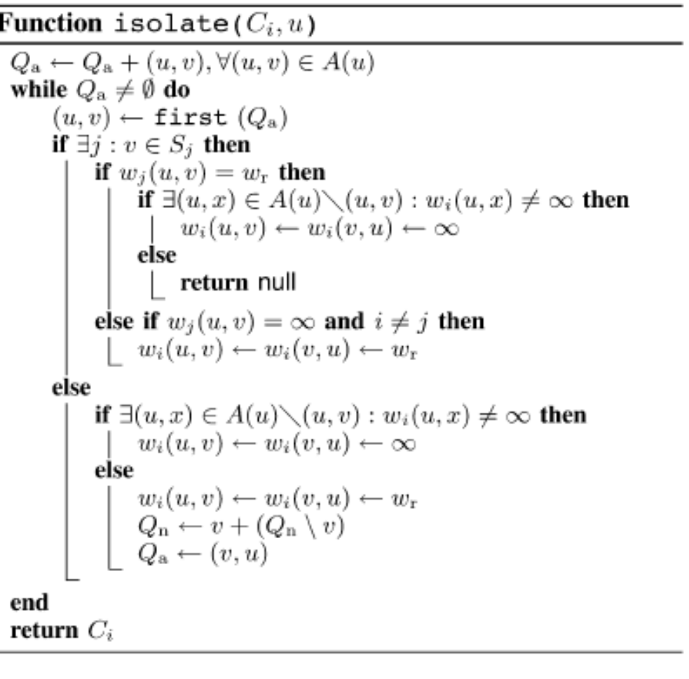

LOCAL FORWARDING PROCESS
Given a sufficiently high  the algorithm presented in Section III will create a complete set of valid backup configurations. Based on these, a standard shortest path algorithm is used in each configuration to calculate configuration specific forwarding tables. In this section, we describe how these forwarding tables are used to avoid a failed component.
When a packet reaches a point of failure, the node adjacent to the failure, called the detecting node, is responsible for finding a backup configuration where the failed component is isolated. The detecting node marks the packet as belonging to this configuration, and forwards the packet. From the packet marking, all transit routers identify the packet with the selected backup configuration, and forward it to the egress node avoiding the failed component.
Consider a situation where a packet arrives at node and cannot be forwarded to its normal next-hop because of a component failure. The detecting node must find the correct backup configuration without knowing the root cause of failure, i.e., whether the next-hop node or link 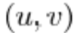 has failed, since this information is generally unavailable.
Let 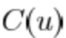 denote the backup configuration where node is isolated, i.e.,  Similarly, let  denote the backup configuration where the link 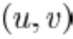 is isolated, i.e., Assuming that node is the egress (or the destination) in the local network domain, we can distinguish between two cases. If  forwarding can be done in configuration  where both and 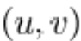 will be avoided. In the other case,  the challenge is to provide recovery for the failure of link 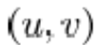 when node is operative. Our strategy is to forward the packet using a path to that does not contain 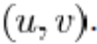 Furthermore, packets that have changed configuration before (their configuration ID is different than the one used in ), and still meet a failed component on their forwarding path, must be discarded. This way packets loops are avoided, also in the case that node indeed has failed. The steps that are taken in the forwarding process by the detecting node  are summarized in Fig. 2.
Assume there is only a single component failure in the network, detected by node on path to the network-local destination via node 
Proposition: Node selects configuration  so that  
Proof: Node selects  in step 2. Node is isolated in 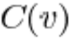 and will not be in the shortest path 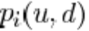.
Proposition: Node  selects configuration  so that 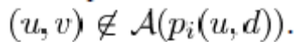
Proof: If  node selects 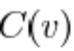 in step 2, and neither node  nor link 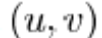 will be in the shortest path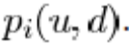.
Assume that is the egress node for destination  Remember that according to (3), We distinguish between three possible cases, illustrated in Fig. 3.
If as in Fig.3(a), then   according to the definition of an isolated node and (2). Forwarding step 2 will select 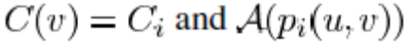 does not contain 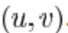 If and 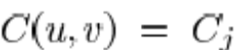 as in Fig. 3(b), forwarding step 2 will select 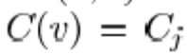 and 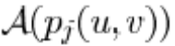 does not contain 
Finally, if as in Fig. 3(c), forwarding step 2 will select 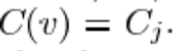 Link 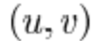 is not isolated in 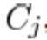 and will be returned as the next hop. Step 3 will detect this, and step 4 will select  and 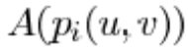 does not contain 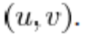

Evaluation of literature survey

We have implemented the algorithm described in Section III-B and created configurations for a wide range of bi-connected synthetic and real topologies.2 The synthetic topologies are obtained from the BRITE topology generation tool [17] using the Waxman [18] and the Generalized Linear Preference (GLP) [19] models. The number of nodes is varied between 16 and 512 to demonstrate the scalability. To explore the effect of network density, the average node degree is 4 or 6 for Waxman topologies and 3.6 for GLP topologies. For all synthetic topologies, the links are given unit weight. The real topologies are taken from the Rocketfuel topology database [20].
For each topology, we measure the minimum number of backup configurations needed by our algorithm to isolate every node and link in the network. Recall from Section III-B that our algorithm for creating backup configurations only takes the network topology as input, and is not influenced by the link weights. Hence, the number of configurations needed is valid irrespective of the link weight settings used. For the Rocketfuel topologies, we also measure the number of configurations needed if we exclude the nodes that can be covered by Loop-Free Alternates (LFA) [21]. LFA is a cheaper fast reroute technique that exploits the fact that for many destinations, there exists an alternate next-hop that will not lead to a forwarding loop. If such alternate paths exist for all traffic that is routed through a node, we can rely on LFA instead of protecting the node using MRC.
Based on the created configurations, we measure the backup path lengths (hop count) achieved by our scheme after a node failure. For a selected class of topologies, we evaluate how the backup path lengths depend on the number of backup configurations.
The shifting of traffic from the normal path to a recovery path changes the load distribution in the network, and can in some cases lead to congestion and packet loss. We therefore test the effect our scheme has on the load distribution after a failure. To do this, we have performed simulations of the European COST239 network [22] shown in Fig. 4, designed to connect major cities across Europe. All links in the network have equal capacity. To achieve a good load distribution and minimize the chances of congestion in the failure-free case, we adopt the link weight optimization heuristic introduced in [23]. They define a piecewise linear cost function  that is dependent on the load  on each of the links in the network. is convex and resembles an exponentially growing function. They then introduce a local search heuristic that tries to minimize the value of by randomly perturbing the link weights. This local search heuristic has been shown to give performance that is close to the optimal solution that can be achieved by a connection oriented technology like MPLS.
The COST239 network is selected for this evaluation because of its resilient network topology. By using this network, we avoid a situation where there exists only one possible backup path to a node. The differences with respect to link loads between different recovery strategies will only be visible when there exists more than one possible backup path. In the COST239 network each node has a node degree of at least four, providing the necessary maneuvering space.
For our load evaluations, we use a gravity-style traffic matrix where the traffic between two destinations is based on the population of the countries they represent [22]. For simplicity, we look at constant packet streams between each node pair. The traffic matrix has been scaled so that the load on the most utilized link in the network is about 2/3 of the capacity. We use shortest path routing with equal splitting of traffic if there exists several equal cost paths towards a destination.

Number of Backup Configurations
Fig. 5 shows the minimum number of backup configurations that Algorithm 1 could produce in a wide range of synthetic topologies. Each bar in the figure represents 100 different topologies given by the type of generation model used, the links-to-node ratio, and the number of nodes in the topology. Table II shows the minimum number of configurations Algorithm 1 could produce for selected real-world topologies of varying size. For the Sprint US network, we show results for both the POP-level and router level topologies. The table also shows how many nodes that are covered by LFAs, and the number of configurations needed when MRC is used in combination with LFAs. Since some nodes and links are completely covered by LFAs, MRC needs to isolate fewer components, and hence the number of configurations decreases for some topologies. We see that for the COST239 network, all nodes except one is covered by LFAs. However, we still need two backup configurations to cover this single node, because isolating all the attached links in a single configuration would leave the node unreachable.

Backup Path Lengths
Fig. 6 shows path length distribution of the recovery paths after a node failure. The numbers are based on 100 different synthetic Waxman topologies with 32 nodes and 64 links. All the topologies have unit weight links, in order to focus more on the topological characteristics than on a specific link weight configuration. Results for link failures show the same tendency and are not presented.
For reference, we show the path length distribution in the failure-free case (“IGP normal”), for all paths with at least two hops. For each of these paths, we let every intermediate node fail, and measure the resulting recovery path lengths using global IGP rerouting, local rerouting based on the full topology except the failed component (“Optimal local”), as well as MRC with 5 backup configurations.

Load on Individual Links
In order to evaluate the routing performance while MRC is used to recover traffic, we measure the throughput on each unidirectional link for every possible link failure. We then find the maximum link utilization over all failures for each link. Five backup configurations were used.
Fig. 8 shows the maximum load on all links, which are indexed from the least loaded to the most loaded in the failure-free case. The results indicate that the restricted routing in the backup topologies result in a worst case load distribution that is comparable to what is achieved after a complete IGP rerouting process.
However, we see that for some link failures, MRC gives a somewhat higher maximum link utilization in this network. The maximum link load after the worst case link failure is 118% with MRC, compared to 103% after a full IGP re-convergence. In the next section, we discuss a method for improving the post failure load balancing with MRC.

RECOVERY LOAD DISTRIBUTION
(a) The link weight assignment used in the normal configuration 
(b) The structure of the backup configurations, i.e., which links and nodes are isolated in each 
(c) The link weight assignments used in the backbones 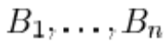 of the backup configurations.

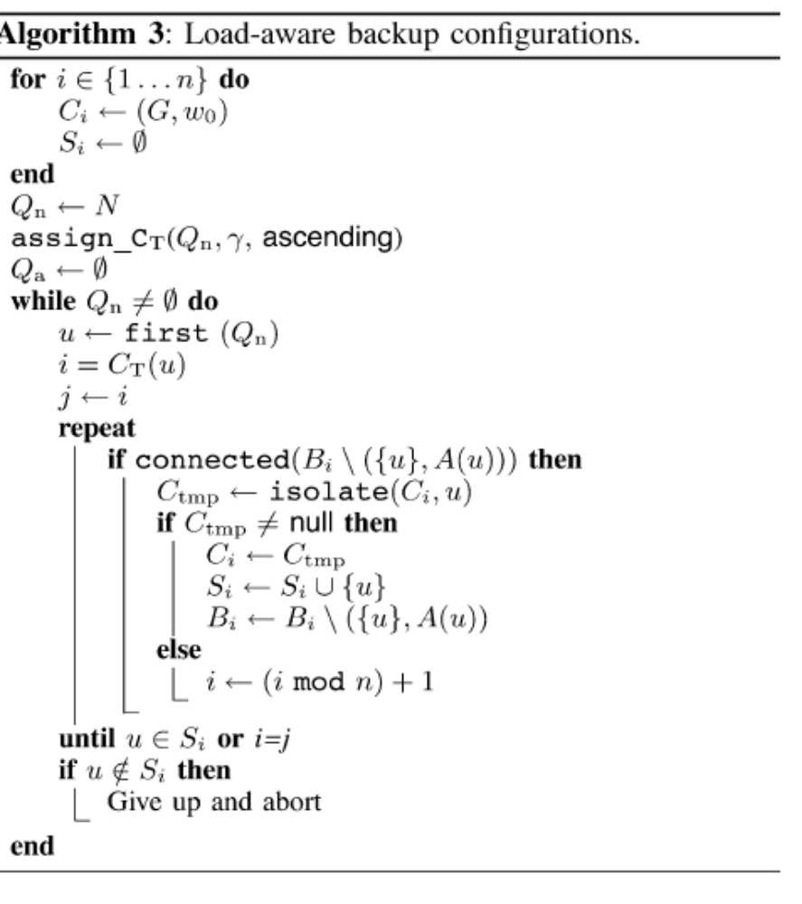

Conclusions:
We have presented Multiple Routing Configurations as an approach to achieve fast recovery in IP networks. MRC is based on providing the routers with additional routing configurations, allowing them to forward packets along routes that avoid a failed component. MRC guarantees recovery from any single node or link failure in an arbitrary bi-connected network. By calculating backup configurations in advance, and operating based on locally available information only, MRC can act promptly after failure discovery

6. REFERENCES

[1]. http://www.zdnet.com.au/whitepaper/0,2000063328,22455213p-16001234q,00.htm
[2]. The Many Faces of Intrusion Detection System by Ameya Anil Valances
https://www.utdallas.edu/~axv028100/courses/cs6390/paper/IDS_paper_may01.pdf
[3]. www.wikipedia.org
[4]. A Survey of Intrusion Detection Systems by Douglas J. Brown, Bill Suckow, and
Tianqiu Wang
[5]. http://www.acm.org/crossroads/xrds2-4/intrus.html
[6].State of the Practice of Intrusion Detection Technologies by Julia Allen, Alan
Christie, William Fithen, John McHugh, Jed Pickel, Ed Stoner (Carnegie Mellon
Software Engineering Institute) January 2000.
www.cert.org/archive/pdf/99tr028.pdf
[7]. NIST (National Institute of Standards and Technology) Special Publication on
Intrusion Detection Systems by Rebecca Bace and Peter Mell.
www.21cfrpart11.com/files/library/reg_guid_docs/nist_intrusiondetectionsys.pdf
[8]. http://techfinder.searchsecuritychannel.com/search/keyword/ttsearchsecuritychannel
/Network+Intrusion+Detection+(IDS)/Network+Intrusion+Detection+(IDS)
[9]. Defending Yourself: The Role of Intrusion Detection Systems by John McHugh,
Alan Christie and Julia Allen. Software Engineering Institute, CERT Coordination
Center
www.cert.org/archive/pdf/IEEE_IDS.pdf
[10]. http://www.isaca.org/Content/ContentGroups/Journal1/20067/Network_Intrusion
_Detection_Know_What_You_Do_(Not)_Need_(JOnline).htm

7. ACKNOWLEDGEMENT

We would like to take this opportunity to sincerely thank Prof.A.yesubabu (Professor, Computer Engineering Dept., SIR CRR COE, and eluru) for giving us a chance to work on such an upcoming and interesting topic and for providing us with his supportive guidance and timely suggestions. We are also very grateful to him for chipping in with his invaluable advice for steering us onto the right track.

